NAAN MUDHALVAN PROJECT

**Cook book:your virtual kitchen assistant**

**1. Introduction**

Project Title: cook book

Team id:NM2025TMID46168

Team leader Name:K. SATHYA

Mail id: sathyak1018@gmail.com

**Team Members:**

1 .R. SHALINI-rajendrenshalini2007@gmail.com- Demo video making

2. S. SNEGA –snegadevi2007@gmail.com-Code Developer

3. M. SRIMATHY –srimathymurugesan6@gmail.com - Document

**2. Project Overview**

Purpose:

SmartCook is a React.js-based online cookbook application that allows users to browse, save, and share recipes. It aims to make cooking easier by providing detailed recipes, step-by-step instructions, and personalized recommendations.

Features:

* Browse recipes by category, cuisine, or ingredients
* Save favorite recipes to personal profile
* Add and edit user-submitted recipes
* Responsive UI for mobile and desktop

# Architecture

Component Structure:

* + Header (navigation bar)
  + RecipeList (list of recipes)
  + RecipeDetail (individual recipe page)
  + Favorites (user’s saved recipes)
  + AddRecipeForm (form to add new recipes)
  + Footer

State Management:

Using React Context API to manage global state for recipes and user favorites.

Routing:

React Router v6 handles navigation between Home, Recipe Detail, Favorites, and Add Recipe pages.

# Setup Instructions

Prerequisites:

* Node.js
* MongoDB
* Git
* React.js
* Express.js – Mongoose – Visual Studio Code Installation Steps

1.Clone the Repository

# Folder Structure

Client:

/src

/components Header.js RecipeList.js RecipeDetail.js AddRecipeF

/pages Home.js Favorites.js

/context RecipesContext.js

/assets images/

Utilities:

* api.js for fetching recipes from API
* helpers.js for common formatting functions

# Running the Application

Frontend:cd client npm start

Backend:cd server npm start Access:[http://localhost:3000](http://localhost:3000/)

# Component Documentation

Key Components:

* + RecipeList: Displays recipe cards fetched from API. Props: recipes[].
  + RecipeDetail: Shows full recipe details. Props: recipeId.

Reusable Components:

* + RecipeCard – used in RecipeList and Favorites.
  + Button – styled button component used throughout the app.

# State Management

Global State:

Managed by RecipesContext for recipes, favorites, and user login status.

Local State:

Form input states managed inside AddRecipeForm.

# User Interface

Include screenshots or GIFs of:

* + Home page showing recipes
  + Recipe detail page
  + Adding a recipe

# Styling

CSS Frameworks/Libraries:

Tailwind CSS for styling; Styled Components for scoped styles.

Theming:

Dark and light mode toggle implemented via context.

# Testing

Testing Strategy:

Jest + React Testing Library for unit and integration tests.

Code Coverage:

Using jest --coverage to ensure 80%+ coverage.

# Screenshots or Demo

Add actual screenshots or a demo link:

* + Demo Link: https://smartcook-demo.netlify.app

# Known Issues

Search filtering may be slow with very large recipe lists. Image upload sometimes fails on slow networks.

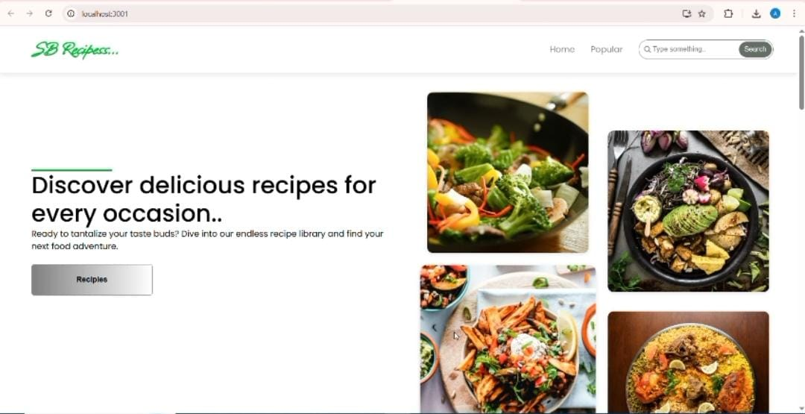

# C:\Users\Vaigai\Downloads\WhatsApp Image 2025-09-16 at 2.24.21 PM.jpeg

# 12.Future Enhancements

Add shopping list generation from recipe ingredients Introduce push notifications for new recipes

Offline mode for saved recipes